University of Petroleum and Energy Studies
School of Computer Science
Department of Cybernetics

Graphics & Animation Tools
VIVA-2
(Session: 2020-2021)

Course: B. Tech with Specialization in Open Source and Open Standards

Submitted To- Submitted By-
Dr. Durgansh Sharma Rahul Raj Baranwal
Associate Professor SAP ID -500061624
Department of Cybernetics Roll No. -R100217054

Q.1 Create any Mountain Range with Snowfall over it using GIMP
Steps: In this experiment we need to create a basic layout of mountain with snowfall with added filters of our choice with the help of GIMP.
- Take a white background of 1080 x 580 pixel.
- And put a slightly smaller black ground to create a black border over it.
- Use the paint bucket tool and brush to draw the range of the mountain and give strokes at certain points to create the peaks for the mountain range. After that fill it in with different colours.
- Now select again the bucket tool and brush and this time select different colour for the mountain range which is going to appear a bit upwards in the background. Always choose a bit lighter peak colour moving upwards.
- Repeat the steps 3 and 4 for multiple times to create mountain range in layered fashion with a beautiful horizon.
For filling mountains with snow
- Select tool up here in your tool box and make sure the mode is on add to current selection and what we're going to be doing is just selecting the sky area of our picture just and what we're going to do is desaturate it a little just so it doesn't look quite as blue because then it'll look more like it could be snowing so just using your fuzzy select we'll just click around in the area of your sky and once you've done that go to colours hue/saturation and lower the saturation to around 50 and then up the lightness to about 20 19 and then just go to select none so once you've done that just duplicate the layer by pressing the icon in your layers window or by going to layer duplicate layer.
- Set your foreground colour as a light blue the blue, set your background colour as a darker blue the HTML date notation for the blue I'm using is 1 b5 a 8f then go to colours matte gradient map and then set the layer mode on to overlay now this blue is a little too intense so I'm just going to lower the opacity of that just a little actually middle to around 40s around 40 you can always adjust that however you want but this just makes it so it gives that kind of cold feel to your image.
- So, now create a new layer and do your bucket fill tool and set your foreground colour is black and just fill that in then go to filters noise HSV noise and the settings I'm using are holding this 3q 180 saturation 0 value 255 just something that looks like this then select okay now as you can tell there's a little too many dots so go to filters blur Gaussian blur and I've learned this by - then go to colours levels and I'm just going to drag my left hand black arrow over a little and then I'm going to drag my tone one over as well and I will drag my white arrow over to so that it's something like this so for the level for the number over here for my black pick point it's 45 my mid-tone arrow is at one point 82 a my white arrow is at 179 you can always play around with this just something that looks like this is
- Go to your layers window and under mode set this layer mode on to screen that just gets rid of that black background now I want it to look like my snow is falling so I'm going to go to filters blur motion blur and I'm going to the links of four you can always increase this or decrease this and you can always adjust the angle however you want I'm just going with an angle of 232 this like okay that just makes it kind of look like your snow is moving not really that much then duplicate this layer.
- Grab your scale tool and just click on the layer and now over here where it says pixels click that and then just like percent make sure this chain thing is locked so this is what it looks like when it's locked and then just set in 200 for the width and then select scale and that just makes our snow look a bit larger and you go to layer transform rotate 180 and that just makes it so that the snow isn't directly on top of each other and that's pretty much it.

- Save the output. And export it in other location with .XCF extension

Output (Rendered Image)
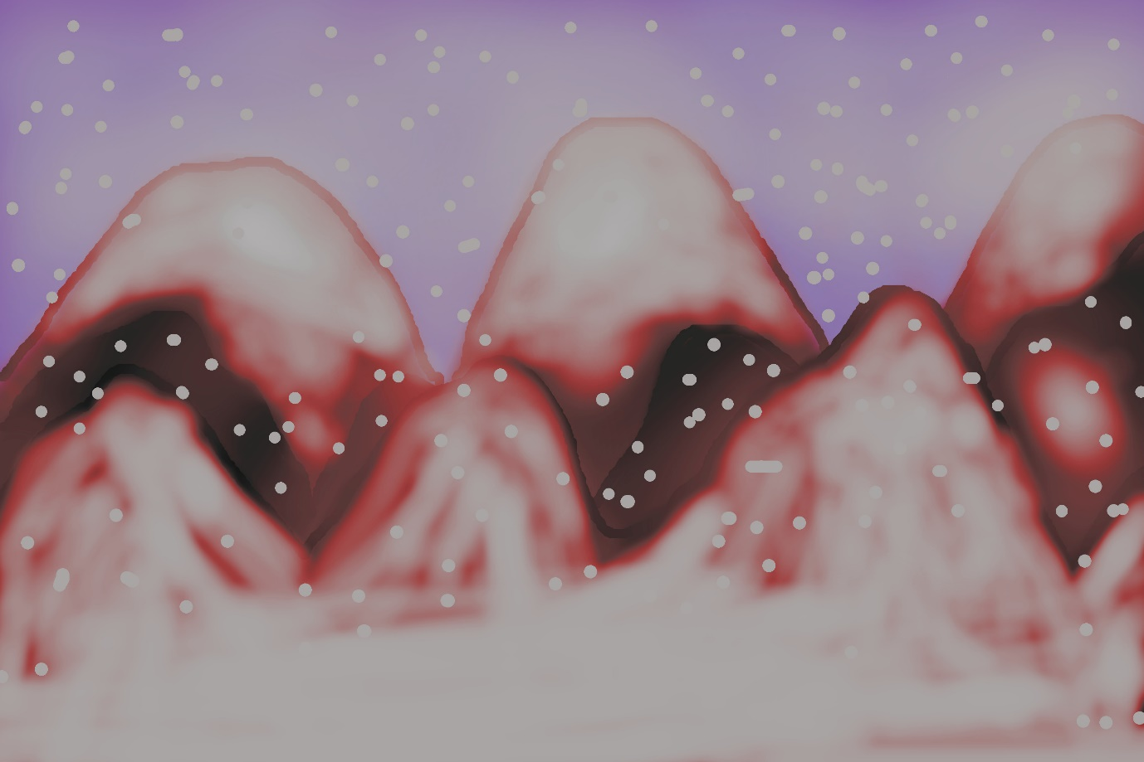
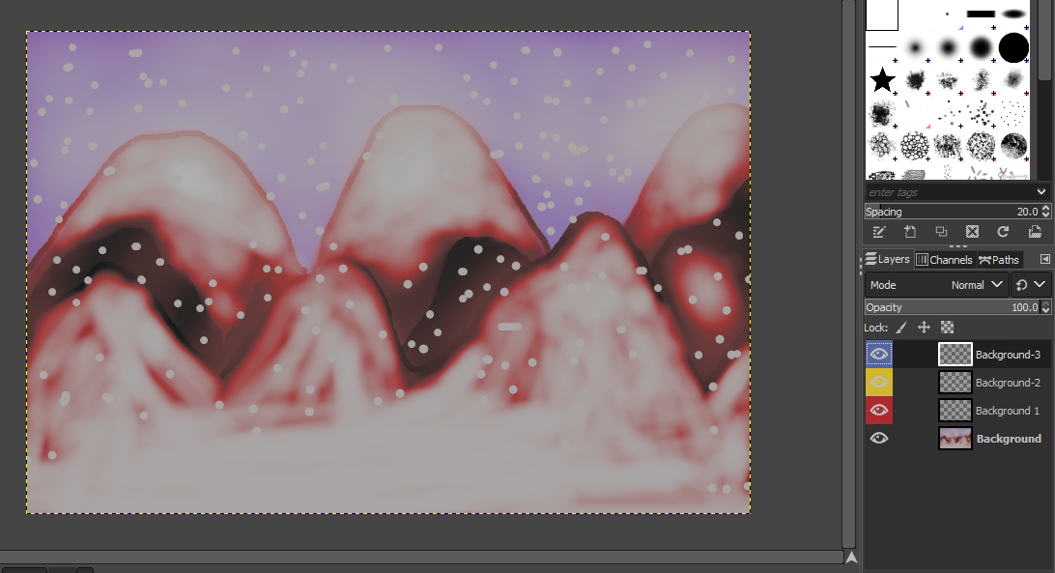

Q.2 Create any City or Skyscraper using Blender
Step-1 we start off with a cube but first off we need to measure the height of an average floor of a skyscraper which is about 3 meters on average so we use the measure tool and measure around 3 meters then we position the cube and a scale it so that it fits the height of 3 meters then we add a loop cut to start defining the frames of the window so WE just add one loop cut by hitting ctrl R right down the middle and then just move it all the way to the edge now they need to do one side only the horizontal side and the vertical side this will represent our window frame
Step-2 We also add a small window frame area for the just a lower part of the window there and then on the side view we turned down the thickness of the window frame so we just now try to define what the window frame was like so now I'm going to face select and select the part where the window is going to be and then just extrude it in a little bit so there's some now stray edges that are left behind by doing that so we just go ahead and delete those ones and we're left with something that looks like this now it looks odd with that with the window frame not having the top and the side area with it but since we want to add in array modifier that will cover it up for us so in the shading settings.

Step-3 I'll just turn on cavity and turn up the ridges and valleys so that we can see everything a little bit better so now I'll go ahead and add an array modifier and as you can see the window frame now looks more complete we also duplicated an extra window frame to the side because we want to use that later on so turning up the array modifier we turn the count to about 8 since we want my floor to be around 16 windows long so the reason why we chose 8 is because later on I'm going to go ahead and use the mirror modifier so now we go ahead and set up the materials as we’ll for the window right now is putting placeholder materials and we just select the pot with the big window and create one material for that and then a small window and create a separate material for that one as then go ahead and select the edges of the window frame and add a little bit of a bell by hitting ctrl be just smooth things out a little bit so once that's done I'll go ahead and apply the array modifier and then we pretty much duplicated and rotated 90 degrees to fit the other corner of the skyscraper

Step-4 Now, this is where the extra skyscraper comes in handy so we'll go ahead and apply the same materials to this one as we’ll should have done that earlier and then we also forgot to add the materials to the back of the windows as we’ll so I'll just do the same thing the reason why is because we want the window to be see through the window we'll have a bit of thickness to the glass so now we rotates the extra pane exactly 45 degrees and then position it to fit the corner of the skyscraper WE do the same to the other side as we’ll so now we have one complete corner done so now I'd go ahead and join all the objects into one mesh by selecting all and then hitting ctrl J

Step-5 Now, from top view you'll notice that the centre point is right in the middle of the blender world on the green and the red axis so we move the mesh so that it doesn't intersect with the green or the red line the reason why is because I
want to go ahead and add a mirror modifier right now and you can see there's a bit of a gap there so now we can move it and make it click into place make sure you turn clipping on in the mirror modifier also take the Y so that will complete the full skyscraper and then in the side view go ahead and make a click into
place but go ahead and move it further in so that you get a window length of about 2 boxes since that's the average length of the window make sure clipping
is turned on now we can create the floor of the skyscraper so for that in edit mode We want to go ahead and add a cube turn down the thickness and then position it all the way so that eclipses right in the middle so now to select the corner verts and then just drag it out to fit the entire floor at this point we have a little bit of
sticking out of the window of the corner area of our skyscraper so we simply just add loop cuts in the cube and then just simply delete the corner verts now just fill up the missing part so that it matches the skyscraper windows we don't show it here but WE also recommend you duplicate that floor and also create the ceiling as we’ll so next we add an array modifier turn off the X to zero and then turn the white one to create the floor for the skyscraper and turn up the count to create as much flows as you want we think we end up choosing something like 35 or 40 to be around the size of the average skyscraper so now position the camera and we finally have our final skyscraper so now it's just a matter of playing around with camera angles and making it look as epic as possible

Step-6 Now, we went ahead and added a hasty our eye image as the world texture so we went to full color with your environment texture and just added the HDR image and then added a multiply and add mode to increase the strength of the Sun and the sky lighting now we went ahead and played around with the materials of the skyscraper for the window frames it was a dark blue color with the metallic almost turned all the way to one and roughness turned almost to zero for the windows the transmission was set to 1 and the roughness we went to almost all the way to zero and we did the same thing for the smaller window as we’ll but we just made the base color of the window a bit of a darker blue

We just went ahead and played around with some settings of every turn up the bloom to enough ambient occlusion but my final render actually ended up being a cycles render this is what my cycles render looks like which is looking quite epic this is where we went ahead and duplicate up the ceiling to create the roof as we’ll so that also mirrored on to the roof pot asell at this point you can pretty much call you skyscraper done that's pretty much all you need to do it's a very simple skyscraper but WE wanted to make him look a little different a bit more reflective WE didn't want to see much of the inside WE have supplied around with different sky lighting WE didn't quite like the look WE was getting from the skyscraper windows so WE just continue playing around with the settings of the principal shader and WE don't know WE didn't really quite find the look that WE wanted to get just ended up looking quite odd

Step -7 Now, try to lean the clearcoat up or try doing some roughness up as we’ll you can play around with the colors eventually we didn't quite like to look we was getting from the principal shader and we changed to a plain old glossy shader mixed with a glass shader we think we like the look of that instead with this Shadrach and sort of seal inside the building but we wanted to be mostly reflective rather than see-through so this point we start to adjust a different camera angle we added a vector mapping node and a texture coordinate to rotate the world a bit move the Sun so that we can see the sunlight and the reflection of the sunlight in the skyscraper eventually we got the look.

Step-8 We finally managed to create a final render of the skyscraper and added some compositing effects like lens distortion and colour grading to create a beautiful output image.

Output (Rendered Images)
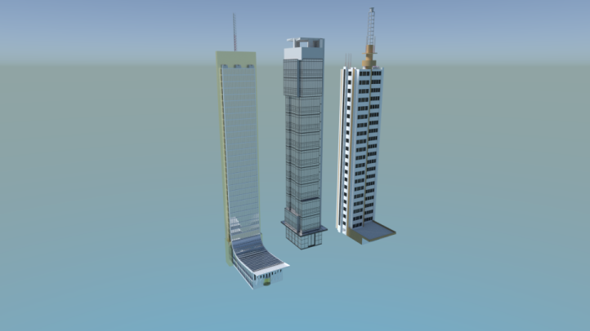

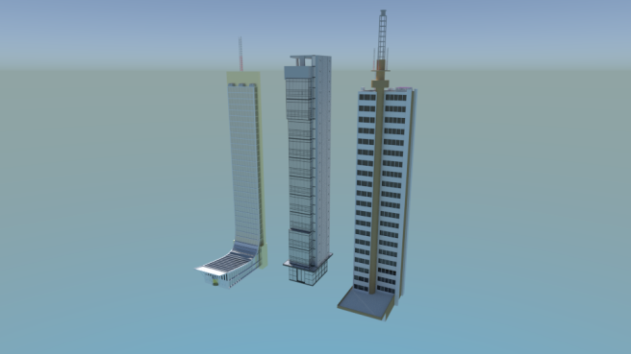

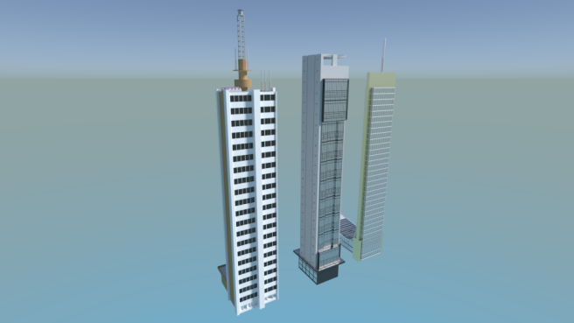

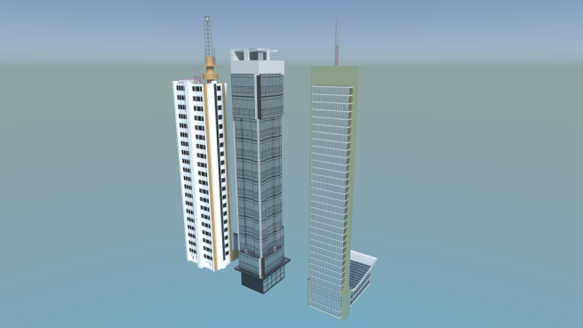

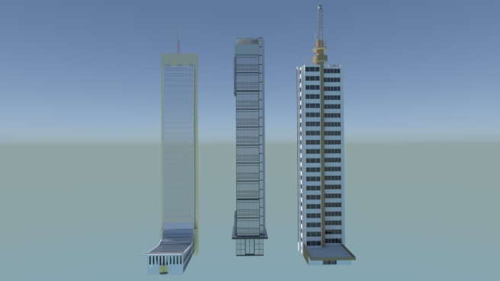

Link for the blender files and Rendered Images:
https://drive.google.com/drive/folders/1gn8jf23otG3q2guqTqu_dEoAsUp7hiID

